Look up and briefly describe the equation your shock enters. Each shock is a one-off increase in the residual of that equation in 2010 Q1. What is the dependent variable, what are the independent variables? What do you anticipate the effect of the shock to be, on your equation’s dependent variable and on the wider economy? [2 marks]
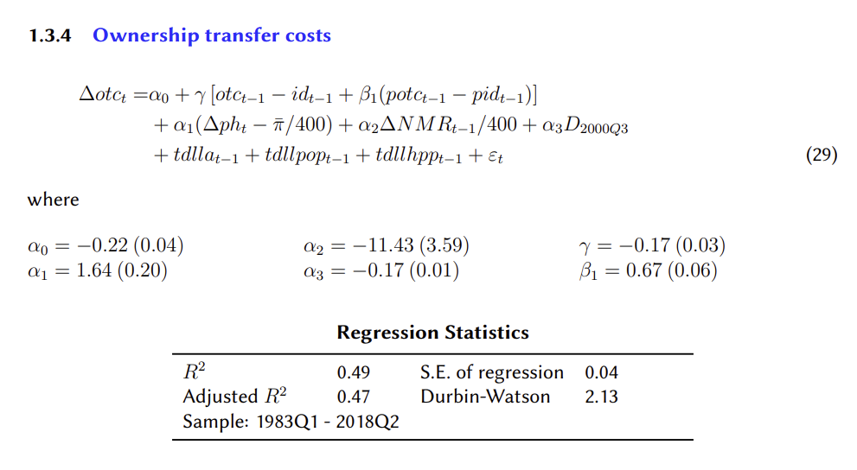
Ownership transfer costs (OTC) are the stamp duties, agents’ commissions and legal fees paid when properties change hands. They are counted as investments in the national accounts and part of GDP identity in the MARTIN paper (4.6 National Account Aggregates). The OTC equation is an error correction model (OLS) with Change in log OTC at time t as the dependent variable. The independent variables are made up of both long run and short run error correction terms. Gamma is the speed of adjustment, it explains how strongly OTC is pulled back toward its long run with dwelling investment (ID) each quarter. Beta₁ is the long run effect of the relative price (both POTC and PID are deflators, hence relative price) on OTC. For instance, a 1 percent increase in the price of OTC relative to ID decreases the real OTC by around 0.67 percent. The short run error correctio terms follow as Alpha₁ is the change in house prices minus the quarterly inflation rate target. When house prices grow faster than inflation in the same quarter then OTC rises. Alpha₂ is last quarters change in mortgage interest rates, which effects this quarters OTC growth. Increasing NMR will lower OTC growth. Alpha₃ is a dummy variable for the introduction of GST in 2000 Q3. Trend labour productivity growth (TDLLA), Trend population growth (TDLLPOP), and Trend change in average hours worked per employee (TDLLHPP) are exogenous variables added so that OTC grows at the economy’s potential growth rate. In the martin txt file c7=1 meaning they are restricted and do not affect the impulse responses. The anticipated effect of the shock on OTC is a 4% rise it is residual in 2010 Q1. I anticipate after the shock OTC will gradually return to its baseline. OTC is a small part of the GDP identity, so GDP would increase slightly, which would lead to slightly less unemployment. Inflation will increase which would lead the central bank to raise the cash rate slight, leading to higher mortgage rates, this would lead to slightly depressed house prices. OTC being only a tiny fraction of the GDP identity suggest small effect and clean impulse response that return to baseline.
Estimate the whole MARTIN model — every equation, as you did for one equation in Assignment 2 — twice: on the original data with the RBA’s sample ending in 2018 Q2, and on the updated data re-estimated to 2026 Q1. With the estimation residuals added back, the model reproduces history; the impulse response is the difference between that baseline and the simulated path after the shock, over 2010 Q1 to 2018 Q2. Compute and plot, for both versions of the model, the impulse responses of: (i) the dependent variable of your equation, (ii) the unemployment rate (LUR), (iii) underlying (trimmed mean) inflation, i.e. the % change in PTM, and (iv) the nominal cash rate (NCR). Use the shock size given in the spreadsheet. [2 marks]
I estimated the whole MARTIN model twice, once up until 2018 Q2 and a second estimation ending in 2026 Q1, the estimation residuals were added back to reproduce the historical data. Conducting an impulse response over 2010 Q1 to 2018 Q2 to illustrate the difference between the baseline and the simulated path of the shock. Bellow is the figure of the four plots with both vintages of historical data. I was given OTC with a shock size of 0.04 (4% rise in OTC). The shock only entered once in 2010 Q1. The difference between the two vintages impulse responses will be due to different re-estimated coefficient estimates.
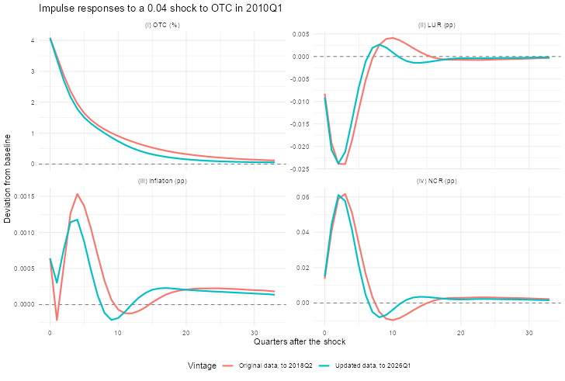

Interpret your results for variables (i) to (iv). Are they in line with your intuition? Are any of them counterintuitive — and if so, what limitations of the MARTIN model might explain that? Do the responses change between the original and the updated data, and why might they? [2 marks]
OTC rises to a peak of 4.08% from the shock, it falls under 1.00% after 8 quarters and declines slowly over the remaining quarters measured, with the updated estimation coming back to baseline quicker than the original. Gamma is estimated to be about -0.17 which is the speed of adjustment back to baseline each quarter. The model estimates a return to baseline which is inline with intuition, additionally the original data is slow to adjust compared with the more up to date vintage, data which can affect policy decisions. The fall in the unemployment rate (LUR) is intuitive as OTC is part of GDP and raising output lowers the unemployment rate which is Okun’s law suggests a one percent change in LUR is associated with a 2-3 percent decrease in real GDP. The original and updated vintages both reach a low point of -0.0239 in percentage points below the baseline. After the third quarter the LUR begins to rise back to the baseline due to the central bank (CB) following its rule and increasing the cash rate. This lifts both LUR curves above the baseline increasing unemployment for about five quarters, as GDP growth falls below trend and leads to a rise in LUR, which is not intuitive. Following LUR returns back toward the baseline for the ongoing quarters. Inflation rises on impact of the shock and peaked after 4 quarters at 0.0015 percentage points whereas the updated data has inflation peaked at 0.012 percentage points in the fourth quarter. The brief fall in inflation in quarter one is counterintuitive, as higher output typically leads to prices increasing. Another counterintuitive point is that inflation dipped below the baseline at the same time as unemployment rose above its baseline. Comparing the two data vintages as the updated data inflation percentage points is brought back to baseline around three quarters earlier. Both vintages then show a rise above the baseline then they slowly return toward the baseline but remain above after 2018 Q2. The nominal cash rate (NCR) is raise immediately peaking at 0.0617 percentage points in the third quarter. As OTC is only a small part of GDP the NCR is brought back to baseline in the sixth quarter, but the NCR undershoots and by roughly 0.01 and then raises back at the baseline. The NCR plot is intuitive and as the LUR increase and Inflation hits below the baseline the NCR is reduced to, and all three variables slowly return toward their baselines. Limitations include that inflation expectations are exogenous the RBA must wait for prices to respond to the labour market. OTC is part of the GDP identity, when it is a transfer cost and adjusts depending on the housing market and the Lucas critique that relationships found in historical data are problematic.

Next, think about how your shock might influence other endogenous variables. Choose two additional variables that are likely to be affected, plot their impulse responses and analyse the results. Are they in line with your intuition? [2 marks]
I chose dwelling investment (ID) and housing prices (PH) which are both endogenous variables and part of the housing sector. Below I have plotted their impulse response for both the original and updated data. Analysing ID there is a sharp drop of around 0.25%, this is unexpected as if OTC increases than that means that more spending on stamp duty, commissions, and other legal fees. This occurs in a bullish housing market as OTC is relative to the price. OTC does not show up in the ID or PH equations, therefore there in no direct link apart from higher GDP, inflation, lower unemployment, CB raises cash rate, bumping up mortgage rates which will lower demand for investing in housing. After six quarters ID rebounds and is back up to the baseline after 14 quarters post shock. The original data over predicts the bottom by just under 10% which is quite large and is corrected by the updated data, the original data also overestimates the rebound which exceeds the baseline. Analysing PH there is a steep drop in prices (-0.25%) followed by a more gradual rebound back toward the baseline but never reaching the baseline by 2018 Q2 due there being a very slow error correction and strong momentum that take a longer run to gain momentum after price decrease for consecutive quarter. Again, the original data overestimates the drop from the shock and the rebound. The updated vintage shows smaller impulses and rebound begin much earlier in the time after the shock, but the rebounds are more gradual to get back toward the baseline.
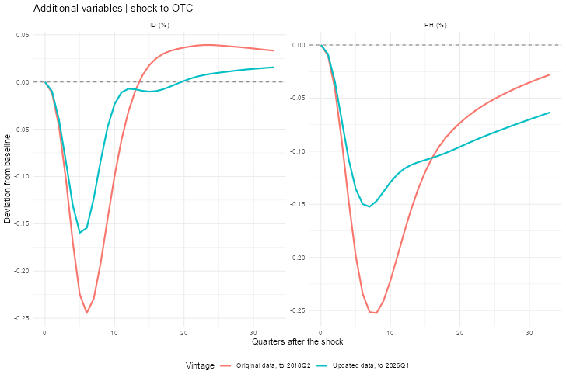
Finally, imagine you are a central banker aiming to stabilise underlying inflation and the unemployment rate. Discuss how a central bank should respond to your type of shock. (Optional, not required for full marks: the sample code also reruns your shock with the cash rate held fixed. Comparing the two shows what MARTIN's own policy rule does, which you can use as evidence for your answer.) [2 marks]
For a positive demand OTC shock of 4 percent, the central bank should react by raising the cash rate and then gradually lowering as the shock dissipates. Because it raises GDP, lowers unemployment, and raises inflation. A temporary positive demand shock shifts the IS curve out to IS’ (staying at IS’ for one period), the economy is producing more than medium-run equilibrium in period 0. The central bank forecasts the PC for period one (over four quarters) shift up and to the left of the initial PC before the shock. The central bank sets a higher interest rate to bring output bellow equilibrium output to Y₁, now The IS curve shifts back gradually to the original IS curve the economy is at the higher inflation lower output where the PC and MR curves are now at equilibrium. The central bank forecasts the PC for period 2, which shifts down as inflation expectation fall and output increase and we see a shift down along the MR curve to the new PC and MR at the CB’s best response in period 2. Period 2 onwards we see that output, inflation, and rates all gradually move back toward the medium-run equilibrium.
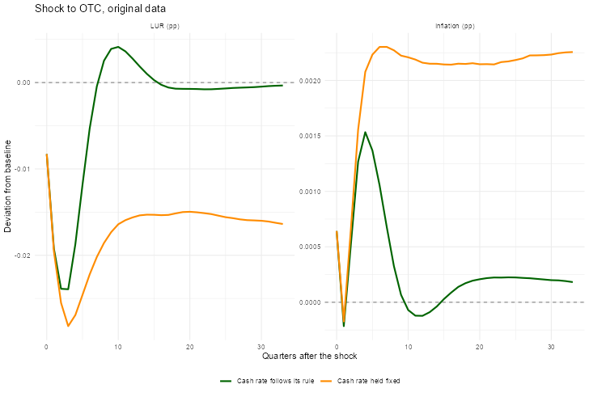
The figure below shows what happens when the cash rate is held fixed which demonstrates why the Taylor principle is important and that the nominal rate must move more than one for one with inflation to move the real interest rate. The Cash held fixed show what happens when there is no MR curve, the inflation and LUR will continue to spiral upward as there is no mechanism to break the cycle, as shown by the orange line.

